
What is CO₂ Laser?
Fractional CO₂ laser is an advanced skin resurfacing treatment. It creates thousands of tiny treatment columns in the skin while leaving surrounding skin intact. This stimulates your body's natural healing response and encourages new collagen formation.

How does it work?
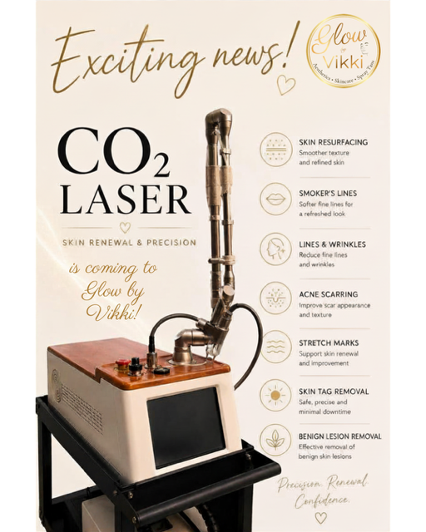
Think of it as creating microscopic 'repair zones' rather than treating the whole surface. The untreated skin between the columns helps speed healing while collagen remodels over the following weeks and months.

What can it treat?
• Skin resurfacing
• Fine lines & wrinkles
• Smoker's lines
• Acne scarring
• Surgical & traumatic scars
• Stretch marks
• Selected benign skin lesions
• Selected skin tags

Who is suitable?
Suitability is decided during a consultation after assessing your skin, medical history and goals. Not every concern is best treated with CO₂ laser, and I will always recommend the most appropriate option for you.

What happens during treatment?
Your skin will be cleansed and prepared before treatment. A personalised treatment plan is used based on your skin and treatment goals. Full aftercare advice is provided.

What is the downtime?
Downtime depends on treatment intensity. Redness, swelling and tiny crusts are expected after fractional resurfacing. Healing varies from person to person, and collagen continues to remodel for several months.

Pricing
Consultation - included
Skin Tag Removal – from £60
Benign Lesion Removal – from £80
Smoker's Lines – from £150
Acne Scars – from £175
Stretch Marks (small area) – from £175
Full Face Resurfacing – from £250
Neck – from £175
Face & Neck – from £395

Why choose Glow by Vikki?
My approach is always conservative, honest and personalised. I focus on healthy skin, natural-looking results and treatments that are appropriate for you. Every recommendation starts with a consultation and a conversation about your goals.

Interested in finding out if CO₂ laser is right for you?
Message Glow by Vikki to book your consultation

